**O’ZBEKISTON RESPUBLIKASI MUDOFA VAZIRLIGI AXBOROT KOMMUNIKATSIYA TEXNOLOGIYALARI VA ALOQA HARBIY INSITUTI**



**HAVO HUJUMIDA MUDOFAA RADIOTEXNIK QO’SHINLAR KAFEDRASI**

**4 -KURS RT-4/5- SEKSIYA**

**“PYTHON DASTURLASH TILI” FANIDAN**

**TOPSHIRIQ**

Bajardi:Artiqov J

Qabul qildi: Sapayev SH.

**1-TOPSHIRIQ**

1**.**Satr berilgan. Satrdagi katta lotin harflari sonini aniqlovchi programma tuzilsin.

satr = input("Satrni kiriting: ")

katta_harf_soni = sum(1 for harf in satr if harf.isupper())

print("Katta lotin harflari soni:", katta_harf_soni)

**Natija:**

Satrni kiriting: Salom DUNYO 456

Katta lotin harflari soni: 6

2**.** n butun soni berilgan (n > 2). Quyidagi ketma - ketlikning dastlabki n ta hadini chiqaruvchi programma tuzilsin.

A1 = 1; A2 = 2; A3 = 3; Ak = AK-1 + AK-2 - 2*AK-3; K = 3,4,...

n = int(input("n butun sonini kiriting (n > 2): "))

A1 = 1

A2 = 2

A3 = 3

if n == 1:

print(A1)

elif n == 2:

print(A1, A2)

elif n == 3:

print(A1, A2, A3)

else:

print(A1, A2, A3, end=" ")

A = [A1, A2, A3]

for k in range(4, n + 1):

A_k = A[k - 2] + A[k - 3] - 2 * A[k - 4]

A.append(A_k)

print(A_k, end=" ")

**Natija:**

n butun sonini kiriting (n>2): 6

1 2 3 3 2 -2

3. Jumlani rostlikka tekshiring: Berilgan uchta butun sonlarning hech bo‘lmaganda bir jufti o‘zaro qarama-qarshi".

a = int(input("Birinchi sonni kiriting: "))

b = int(input("Ikkinchi sonni kiriting: "))

c = int(input("Uchinchi sonni kiriting: "))

if a + b == 0 or a + c == 0 or b + c == 0:

print("TRUE")

else:

print("FALSE")

**Natija:**

Birinchi sonni kiriting:5

Ikkinchi sonni kiriting:-5

Uchinchi sonni kiriting:10

TRUE

**2- TOPSHIRIQ**

Butun sonlar fayli berilgan. Fayldagi sonlar biror belgi bilan ajratib yozilgan.Undagi barcha juft elementlari o’chirilsin.

b = []

file = open("D:\\Artiqov\\a.txt",'r')

f = list(map(int, file.read().split(".")))

for i in f:

if i%2==1:

b.append(i)

file = open("D:\\Artiqov\\b.txt",'w')

file.write(str(b))

file.close()

**Natija:**

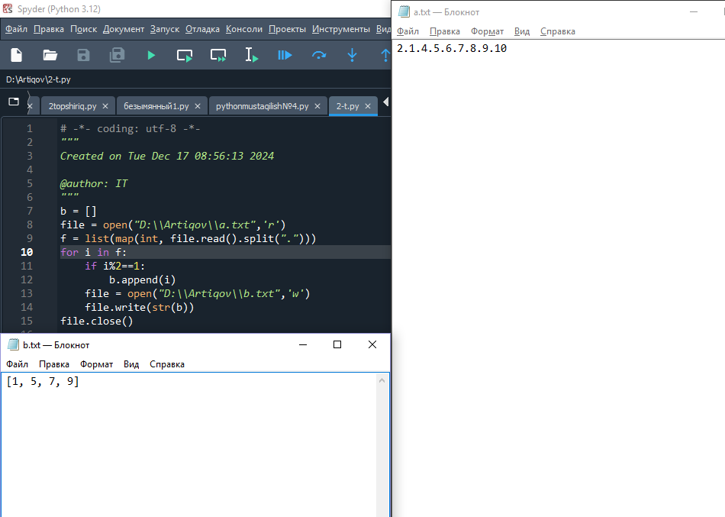

**3-TOPSHIRIQ**

n ta enelentdan iborat massiv hosil qiling . Massivning barcha lokal maksimumlarini nolga aylantiruvchi dastur tuzing. o'ng va chap qo'shnilaridan katta bo'lgan elemen lokal maximum deyiladi

def lokal_maximum_nolga(massiv):

n = len(massiv)

for i in range(1, n - 1):

if massiv[i] > massiv[i - 1] and massiv[i] > massiv[i + 1]:

massiv[i] = 0

return massiv

def main():

n = int(input("Massivning uzunligini kiriting: "))

massiv = []

print("Massiv elementlarini kiriting:")

for i in range(n):

element = int(input(f"Element {i+1}: "))

massiv.append(element)

print("Asl massiv:", massiv)

massiv = lokal_maximum_nolga(massiv)

print("Lokal maksimumlar nolga aylantirilgan massiv:", massiv)

**Natija:**

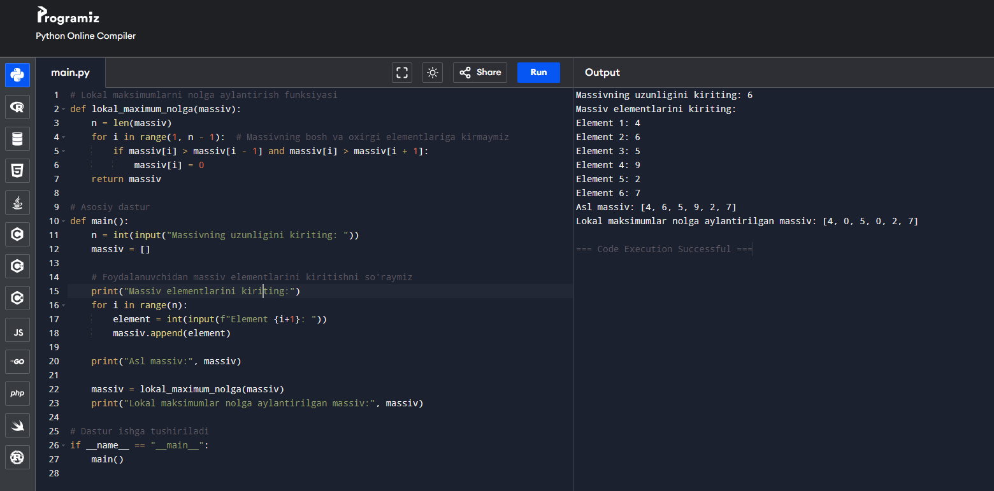

**4-TOPSHIRIQ**

Ikki xonali son berilgan.Uning raqamlari o’rnini almashtirishdan hosil bo’lgancsonni aniqlovchi programma tuzilsin.Dastur pyqt5 paketidan foydalanib tuzilsin

from PyQt5 import QtWidgets,uic

app=QtWidgets.QApplication([])

ui=uic.loadUi("artiqovmi4.ui")

ui.setWindowTitle("sonni ornini almashtirish")

def son():

a=int(ui.birinchison.text())

x=a//10

y=a%10

z= y*10+x

ui.ozgarganson.setText(str(z))

ui.push.clicked.connect(son)

ui.show()

app.exec_()

**Natija:**

